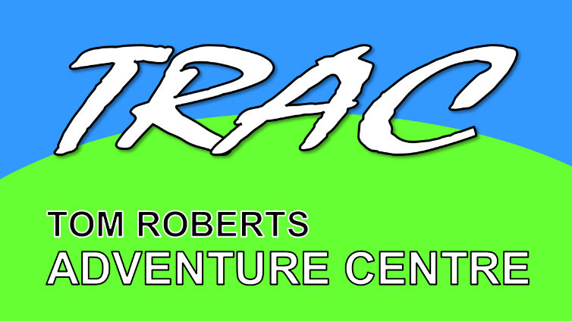
Tom Roberts Adventure Centre
Yates Farm, Malswick, Newent Gloucestershire, GL18 1HE
www.tracnewent.org.uk
MINOR INJURIES UNIT (MIU)
Minor Injuries Units at community hospitals treat a variety of injuries and illness for adults and children. No appointment is needed.
If your injury is not serious you can get help from a MIU rather than emergency department. By doing so you allow emergency department staff to concentrate on people with serious and life-threatening conditions and save yourself a potentially long wait.
We encourage patients who need to be seen in MIU to contact NHS111 online or over the phone first of all.
All opening times are subject to change, but by ringing 111 you will be able to check whether the unit is open as planned.
The MIU team specialise in:
- Sprains
- Simple fractures needing x-rays and plasters
- Simple wounds that may need stitches
- Minor burns
- Emergency contraception
- Minor head injuries with no loss of consciousness
- Minor illness, earache, sore throat, etc.
- Skin problems such as rashes, bites, stings and infections
- Eye conditions including foreign bodies and conjunctivitis
Nearest Minor Injury Units:

- Ledbury Community Health Monday – Sunday 07:45 – 17:45
Market St, Ledbury HR8 2AQ 19 minutes – 10 Miles
01531 632488

- Forest of Dean Community Hospital Monday – Sunday 0800 -1930
Steam Mills Rd, Cinderford, Gloucester GL14 3HY 25 Minutes – 12 Miles
0300 421 2121

- Tewkesbury Hospital Monday – Sunday 0800–1930
Barton Rd, Gloucestershire, Tewkesbury GL20 5GJ 28 Mins - 14 Miles
0300 421 6100

NEAREST A&E

- Gloucester Royal Hospital 24 Hours
Great Western Rd, Gloucester GL1 3NN 22 Mins – 10 Miles
0300 422 2222

- Cheltenham General Hospital *
College Road Wing, GL53 7AN 36 Mins – 16 Miles
0300 422 3046
*Cheltenham A&E has a consultant-led Emergency Department from 8am - 8pm and a nurse-led Minor Injuries and Illness Unit (MIIU) from 8pm - 8am
24 hour emergency care and specialist children’s services are based at Gloucestershire Royal Hospital A&E.
Should I go to Cheltenham A&E?
At night time (8pm - 8am), Cheltenham A&E is for minor injuries only, which include:
- sprains
- cuts
- grazes
- bites
- stings
- burns and scalds
- simple or suspected breaks and fractures
- minor illnesses
If you need medical advice or treatment, but you’re not sure where you should go, visit 111.nhs.uk or ASAP Glos for guidance.
Where should I take a child in an emergency?
If your child is critically ill or needs to go to hospital, call 999 (what3words address of the front gate is: royally.archive.downs) and they will be taken by an ambulance to Gloucestershire Royal Hospital’s A&E department.
All ambulances will take children to Gloucestershire Royal Hospital at any time of day or night. You can also bring your child to Gloucestershire Royal Hospital A&E at any time.
This is where specialist children’s staff are based, and they can provide your child with the care they need.
You should only bring your child to Cheltenham A&E if:
- your child doesn’t need to be admitted to a ward, for example they have a sprained ankle
- your child needs treatment for a minor injury or illness
- you’re bringing your child in before 8pm (there are no specialist children’s facilities at Cheltenham A&E after 8pm)

